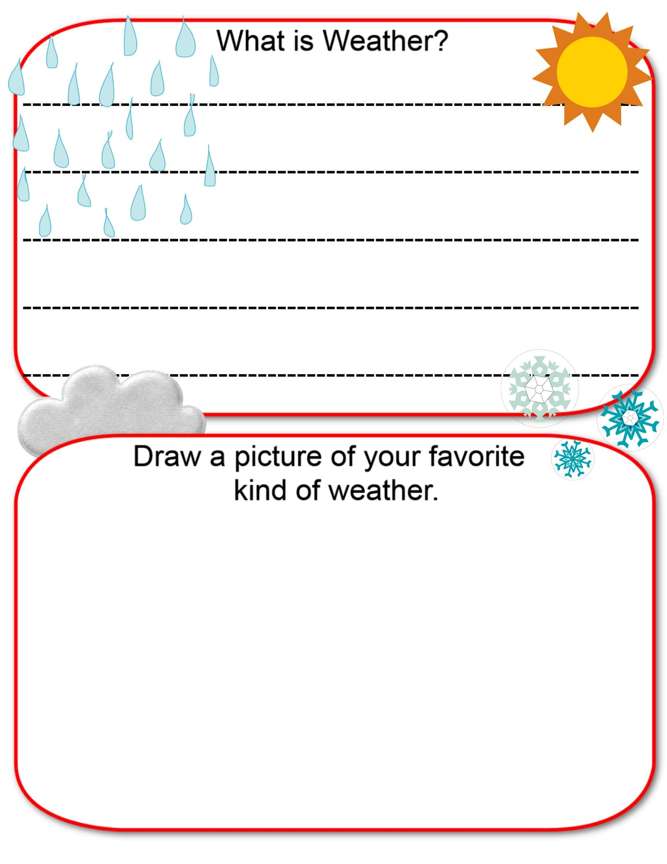

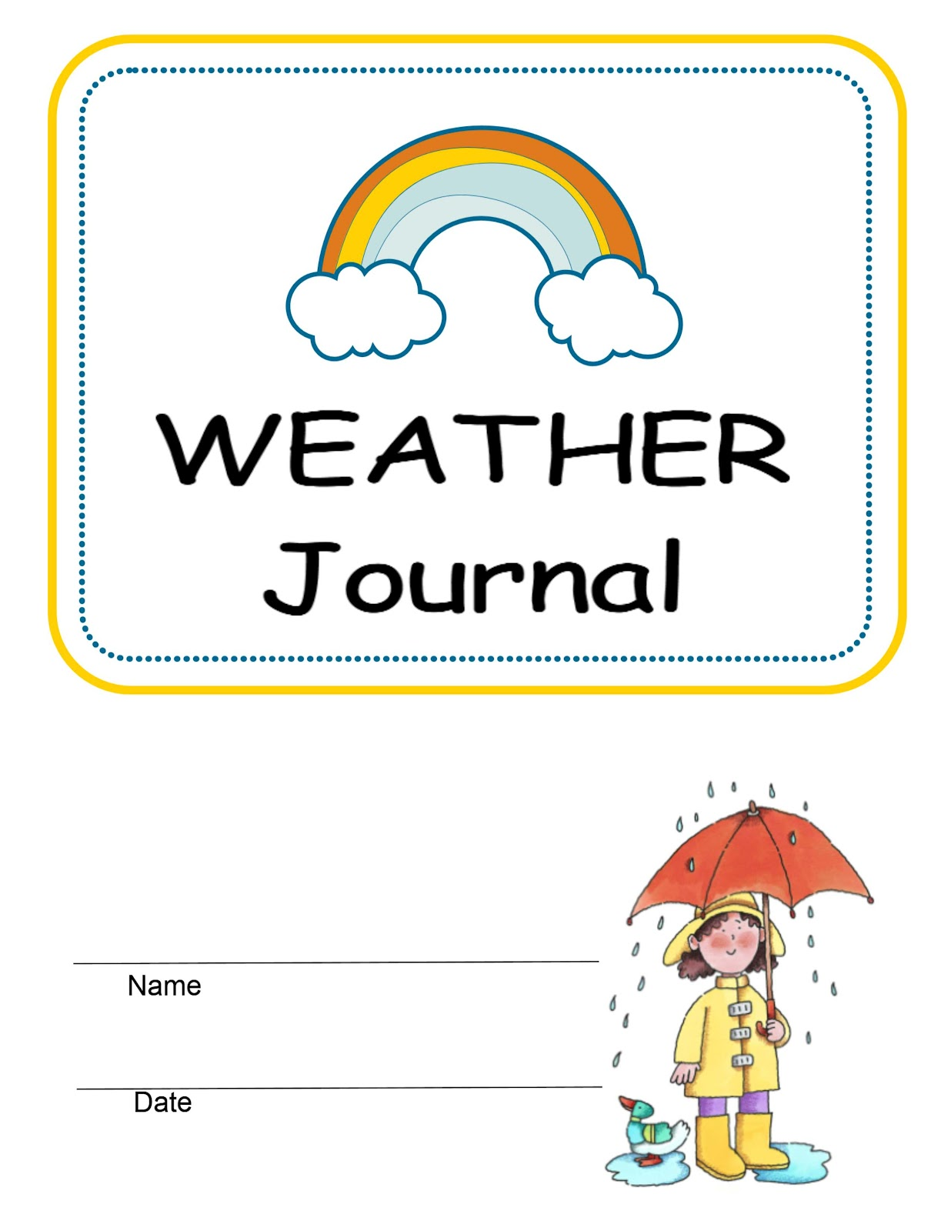

Today’s Date: ­­­­­­­­­­­­__________________________  
Today’s Weather is _____________________ __________________________________________________________________________________________________________________

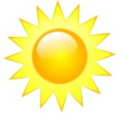 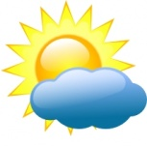  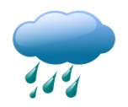 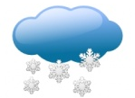

Temperature is: __________

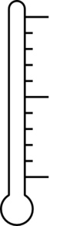

Draw a picture of what today’s weather looks like:

|  |  |  |  |  |  |
| --- | --- | --- | --- | --- | --- |
| Weather Graph | | | | | |
| 14 |  |  |  |  |  |
| 13 |  |  |  |  |  |
| 12 |  |  |  |  |  |
| 11 |  |  |  |  |  |
| 10 |  |  |  |  |  |
| 9 |  |  |  |  |  |
| 8 |  |  |  |  |  |
| 7 |  |  |  |  |  |
| 6 |  |  |  |  |  |
| 5 |  |  |  |  |  |
| 4 |  |  |  |  |  |
| 3 |  |  |  |  |  |
| 2 |  |  |  |  |  |
| 1 |  |  |  |  |  |
|  | Sunny | Partly Cloudy | Cloudy | Rain | Snow |