Name: ____________________________

Weather Matching
Match the picture on the left with the word on the left that best describes the picture.

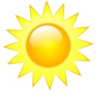

Rainy

Cloudy
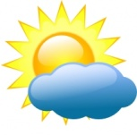

Snowy

Sunny
Partly
Cloudy
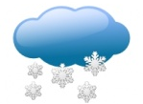

Weather Calendar
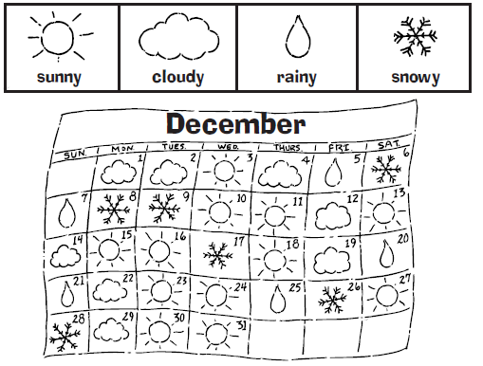
Look at the calendar and answer the questions below.

How many sunny days did they have? ___________________________
How many cloudy days did they have? __________________________
How many rainy days did they have? ____________________________
How many snowy days did they have? ___________________________
Which kind of weather did they have the most of? _________________
Types of Weather
Draw three types of weather and write about each of them.

